LAB SHEET - 07

**Name : Nikini Kodithuwakku Arachchi**

**Index : 30592**

**Batch No : 23.1**

**Degree Program Name : Computer Network**

Q1.

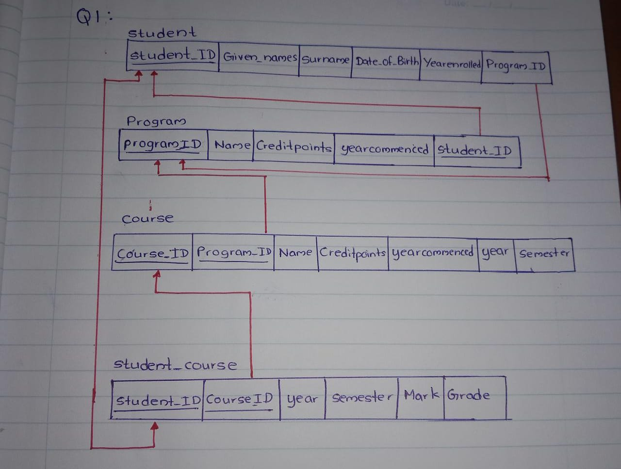

Q2

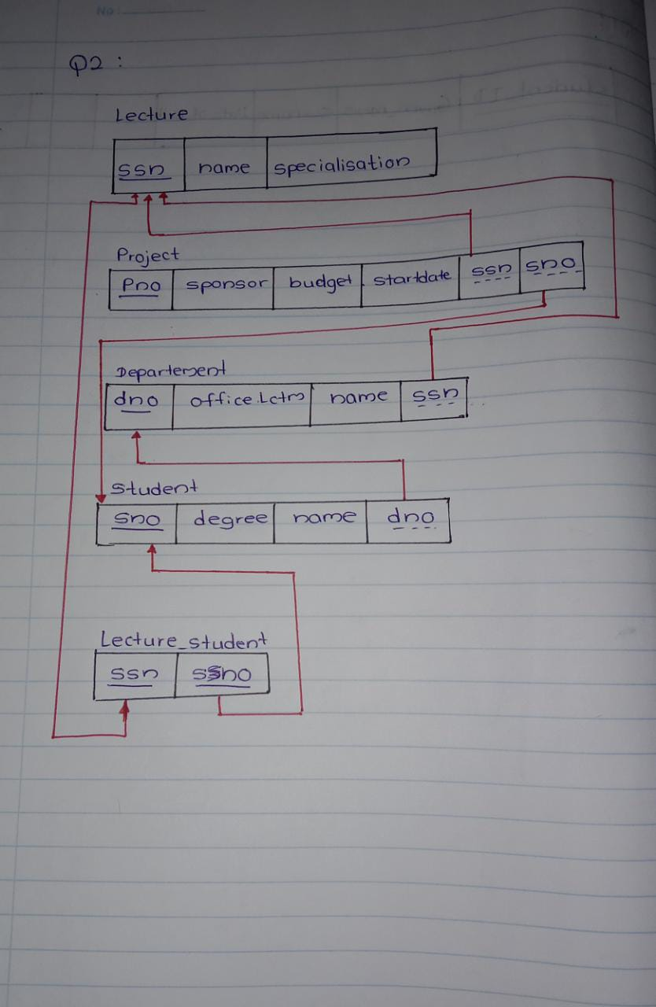

Q3

